GPRS 3-Phase Tests and Hysteresis Implementation

Yaqing Fan
Jan 25th, 2006

Summary

A three phase relative permeability model, known as Stone-1 model has been implemented into GPRS, with which the default segregation model was corrected and reorganized. Additionally, hyteresis has been developed for both two phase and three phase problems. We have got matched results with Eclipse on these new features. However, there are three problems found during tests: black-oil variable bubble point problem, GPRS initialization problem and three phase hysteresis in WAG process.

1. GPRS 3-Phase Tests

(1). Three Phase Relative Permeability Models

There was only segregation model in GPRS to calculate three phase relative permeabilities. Extensive tests showed that the segregation model worked well after debugging. The unmatched results from Eclipse 100 and GPRS Black-Oil Model did not come from relative permeability calculation but come from variable bubble point problem.
The default segregation model is also called Baker’s model, which is the same one implemented by Aurelie. Stone’s 1st model has also been implemented and tested for a number of cases. The results showed that Stone’s 1st model and the segregation model did not lead to dramatically different curves, such as oil production rate.
In the input file, if segregation model is to be used, nothing needs change. If the Stone’s 1st model is to be used, one only has to type “STONEI” after the relative permeability tables.
Example:
# --- Three phase relative permeability model ----

STONEI

(2). Three Phase Black Oil Tests

The current GPRS three phase black-oil sample does not match Eclipse. The following plots show how curves from GPRS deviate from Eclipse results. What’s more, GPRS can only calculate no more than 3200 days.
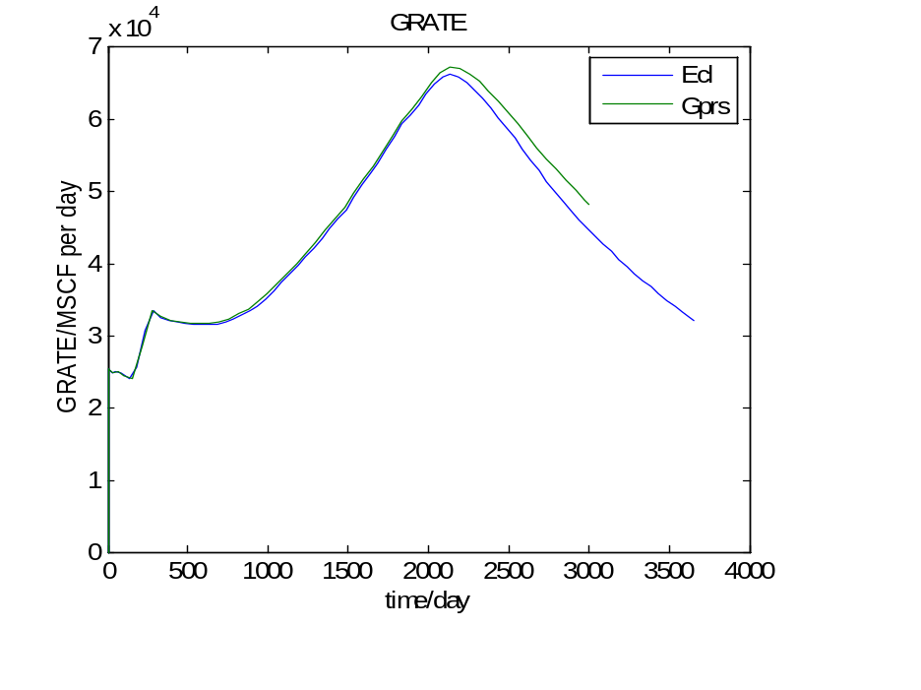
Fig 1(a). Old GPRS 3-phase black oil sample
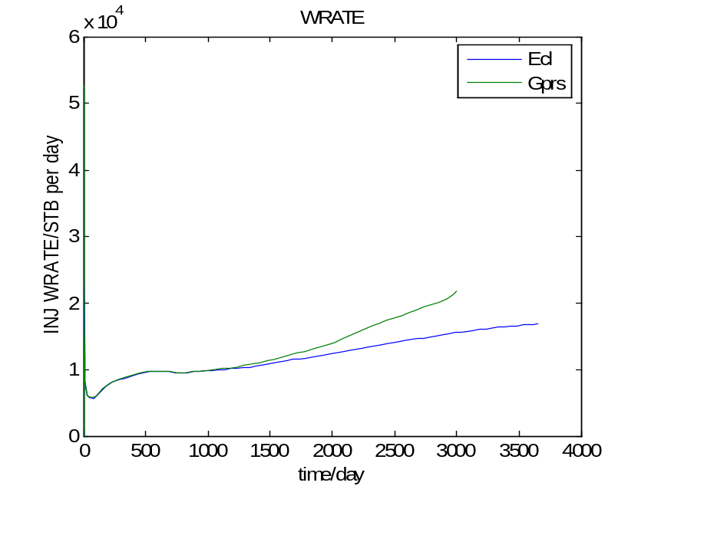
Fig 1(b). Old GPRS 3-phase black oil sample

This case has been recalculated with newly developed Stone’s 1st model. Although the results, shown in Fig 2, are better than those from segregation model, they are not correct because of negative gas saturation at around 20 years.
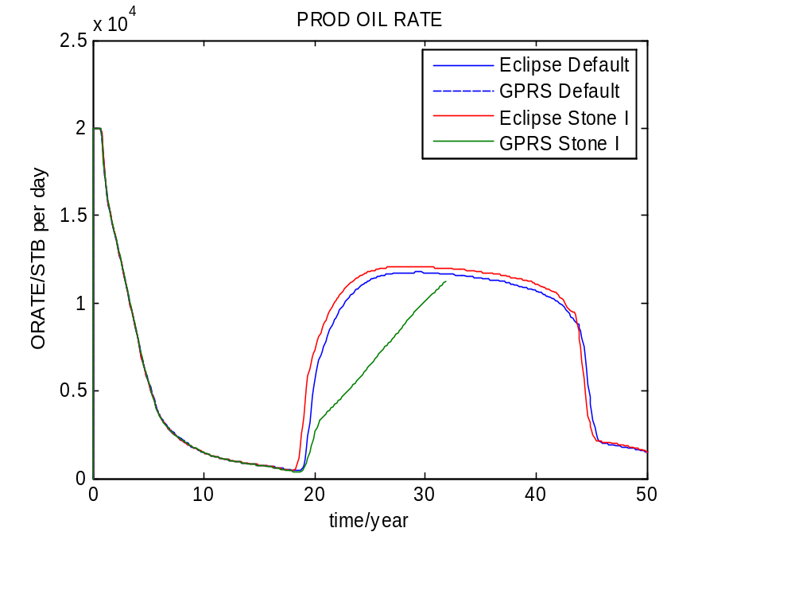
Fig 2(a). GPRS 3-phase black oil sample with Stone’s 1st model
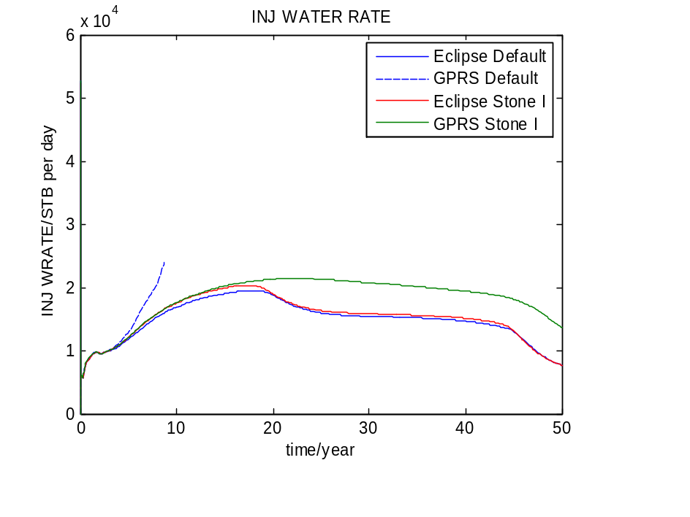
Fig 2(b). GPRS 3-phase black oil sample with Stone’s 1st model

(3). Three Phase Compositional Tests

In the compositional cases, GPRS has a very strict requirement of saturation tables. Generally, GPRS can run smoothly if the relative permeability is smooth and the derivatives at endpoints are zero. Also, GPRS has a different treatment in initialization than Eclipse. In GPRS, the reservoir must lie between GOC and WOC; in addition, the initial water saturation is set to Swi (which is input by user) at all blocks. The following table shows the initialization difference in the GPRS compositional sample case.
Table 1.Comparison of GPRS and Eclipse Initialization
 |  | Eclipse | GPRS
Pressure | Block i | 501.353 | 501.394
Pressure | Block j | 523.008 | 523.665
Sw | Block i | 0.080142 | 0.12000
Sw | Block j | 0.082967 | 0.12000
Sg | Block i | 0.36598 | 0.34922
Sg | Block j | 0.34165 | 0.326292
So | Block i | 0.55387 | 0.53078
So | Block j | 0.57538 | 0.553708
Albeit the difference of initialization, we can use the GPRS initialization data as Eclipse input to force them to calculate from the same initial values. The results are matched very well after debugging, as shown in Fig 3.
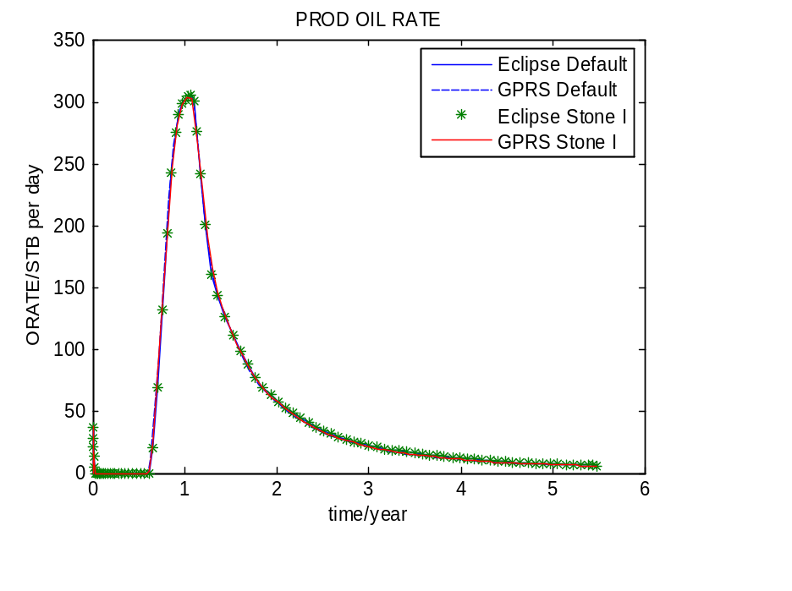
Fig 3(a). GPRS 3-phase compositional sample
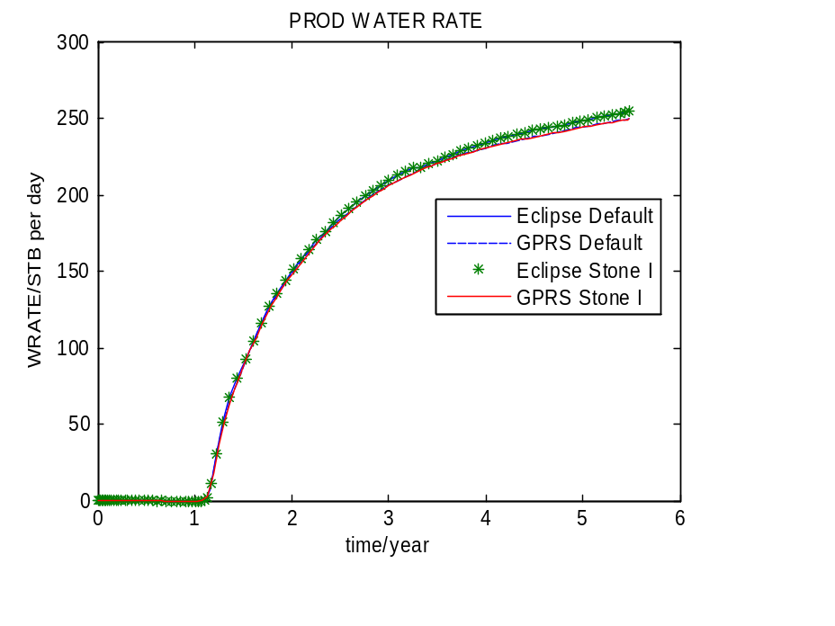
Fig 3(b). GPRS 3-phase compositional sample
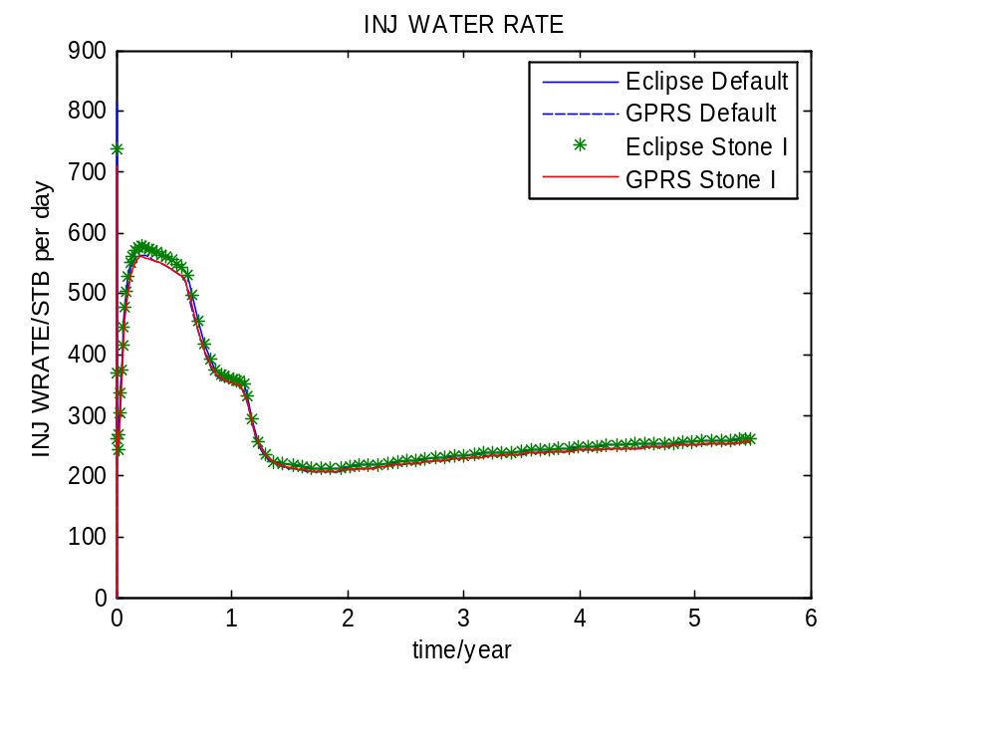
Fig 3(c). GPRS 3-phase compositional sample

In conclusion, both the default segregation and Stone’s 1st relative permeability models work well. And the difference in the black oil case came from negative saturation problem, which is caused by variable bubble point.

2. Hysteresis Implementation

Hysteresis has been implemented for both two-phase and three-phase in the GPRS and matched results have been obtained to Eclipse. However, one of the three-phase hysteresis models, WAG hysteresis developed by Skauge and Larsen, runs very unstably in GPRS. In fact, this is a common problem also mentioned in literature.

(1). Hysteresis Model

A typical plot of relative permeability is shown below, where 1 to 2 and 2 to 3 are primary drainage curve and primary imbibition curve input by user. Consider a process of decreasing non-wetting phase followed by increasing non-wetting phase. The non-wetting phase relative permeability will increase following the primary drainage curve. If at some point lower than the maximum non-wetting phase saturation, for example, point 4, the non-wetting phase saturation starts to decrease, the relative permeability will follow a scanning curve from 4 to 5. If a secondary drainage process happens, the scanning curve will be retraced until the non-wetting phase saturation exceeds the maximum historical non-wetting phase saturation, for example, point 4.
Carlson’s method to calculate scanning curve has a interpretation in terms of geometry. The scanning curve can be generated by shifting the primary imbibition curve horizontally and be cut from the intersection between primary drainage curve and shifted imbibition curve.

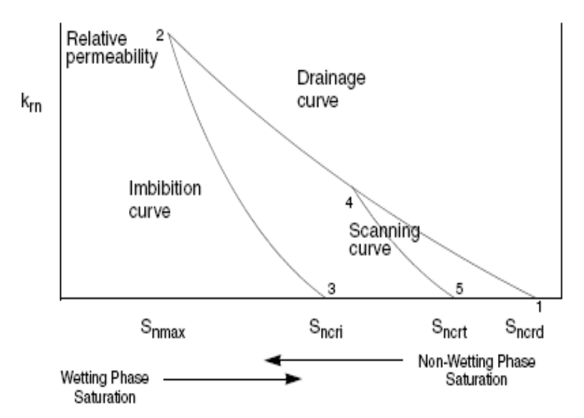
Fig. 4 A typical non-wetting phase relative permeability with hysteresis

There is a consistency requirement for the primary imbibition curve. Carlson’s method is developed based on Land’s trapping model. Consider gas phase as non-wetting phase. In Land’s model, the non-wetting phase trapped critical saturation is calculated by
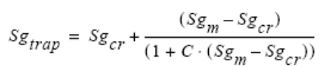 (1)
and the relative permeability is given by
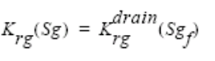 (2)
where
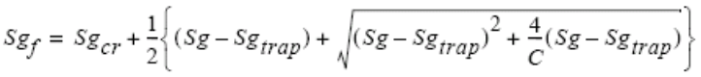 (3)
In these equations, 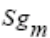is the maximum gas saturation reached before in the block (point 2 in Fig 4), 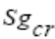is the critical gas saturation (point 1 in Fig 4). Therefore, given the primary drainage curve and Land’s coefficient C, the primary imbibition curve is solely determined. In GPRS, if Land’s model is used, one only needs to input
# --- Hysteresis ----
#HystFLag Model C
HYST LAND 1.3636

If Carlson’s method is to be used, one has to generate the primary imbibition curve and input as a two dimensional table
# --- Hysteresis ----
#HystFLag Model
HYST CARLSON

NUM_OF_TABLE_ENTRIES 23

# Sg Krg_imb
0 0
0.0400 0
0.0800 0
0.1200 0
0.1600 0
0.2000 0
0.2400 0
0.2800 0
0.3200 0
0.3600 0
0.4000 0
0.4400 0.0481
0.4800 0.1055
0.5200 0.1700
0.5600 0.2411
0.6000 0.3179
0.6400 0.3999
0.6800 0.4877
0.7200 0.5803
0.7600 0.6779
0.8000 0.7808
0.8400 0.8882
0.8800 1.0000

Another model initiated by Larsen and Skauge, known as WAG hysteresis model, is also implemented in GPRS. However, it runs very unstable, incurring difficulty in flash calculation.

(2). Two Phase Cases

Both two phase black-oil and compositional models have been compared with GPRS. Matched results have been reached.
Let’s see a two phase black-oil case. In this case, the reservoir was initially saturated with oil and water was injected under BHP control in one corner. One producer is located in the opposite corner. Here are the results.
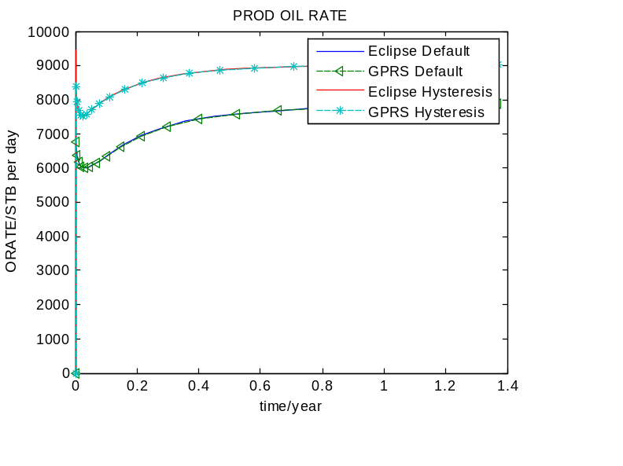
Fig 5(a). Black oil case with hysteresis
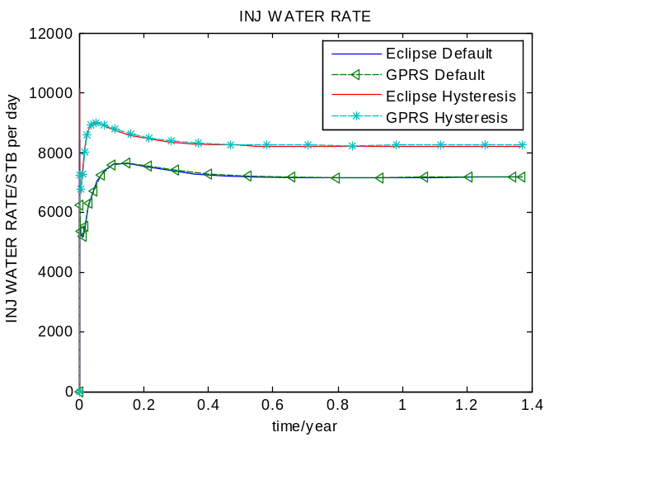
Fig 5(b). Black oil case with hysteresis

Here is another two phase compositional case results:
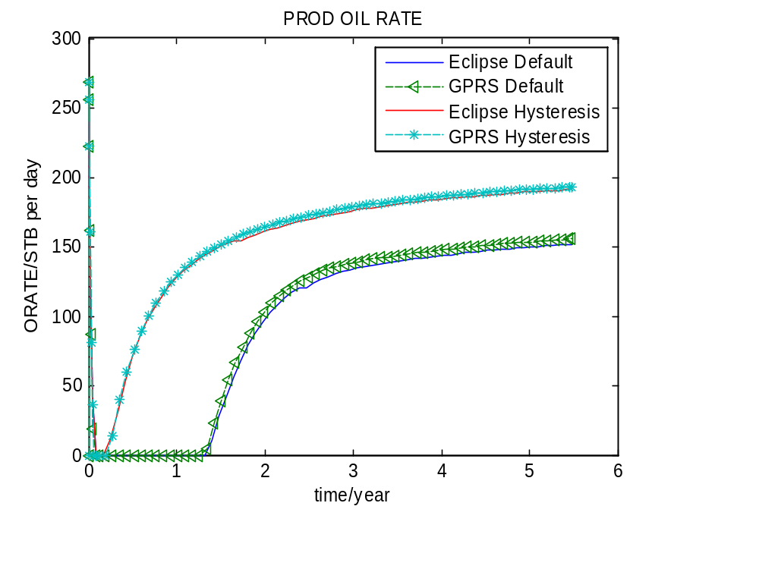
Fig 6(a). Two phase compositional case with hysteresis
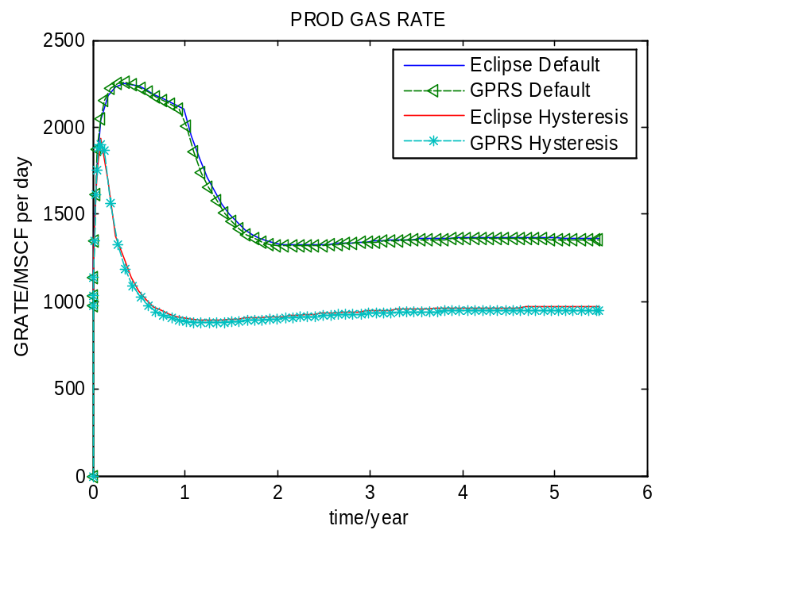
Fig 6(b). Two phase compositional case with hysteresis

In these cases, the effect of trapping non-wetting phase is obvious.

(3). Three Phase Cases

For black oil cases, since we have variable bubble point problems, we only consider compositional model here. The comparison between the results of the sample case with hystesis and those without hysteresis is shown in Fig 7.
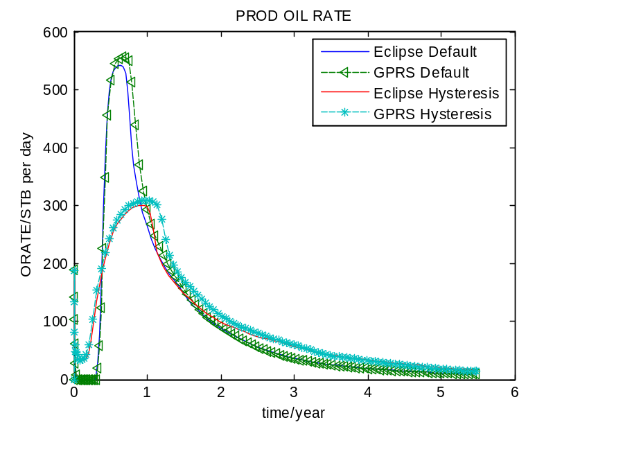
Fig 7(a). Three phase compositional case with hysteresis
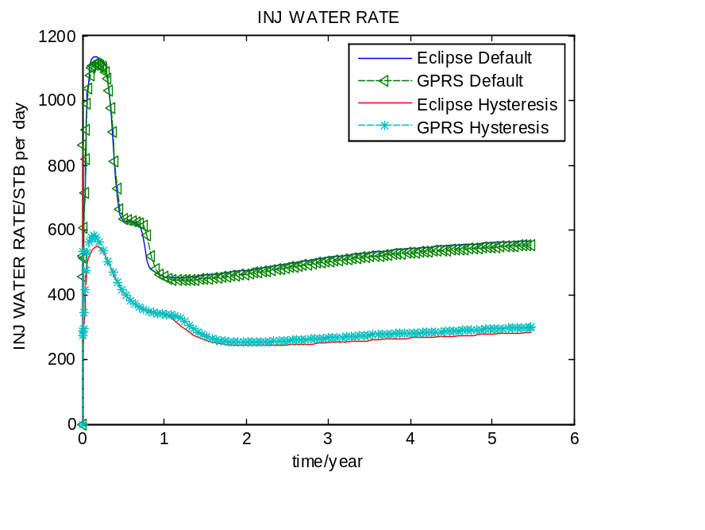
Fig 7(b). Three phase compositional case with hysteresis

Conclusions

Three-phase cases have been investigated for both black oil and compositional model in GPRS with improved relative permeability models. The compositional case results matched Eclipse given the same initialization and smooth relative permeability curves. Hysteresis has been developed and tested for many cases, most of which matched Eclipse very well, although GPRS has some trouble in dealing with WAG process.

References:

[1]. Larsen, J.A, and Skauge, A., “Methodology for Numerical Simulation With Cycle- Dependent Relative Permeabilities”, SPE Journal, June 1998, p. 163-173.
[2]. J.R.Christensen et.al., “Compositional Simulation of Water-Alternating Gas Processes”, SPE 62999, Texas, October, 2000
[3]. C.A. Kossack, “Comparison of Reservoir Simulation Hysteresis Options”, SPE 63147, Texas, October, 2000
[4]. Carlson, F.M. “Simulation of Relative Permeability Hysteresis to the Non-wetting Phase”, SPE 10157, San Antonio, Texas, October, 1981
[5]. Eclipse Technical Description, Schlumberger GeoQuest, 2005

